**How to make multiple cards using json file data ?**

Suppose we want to make multiple cards or something else using json file data then what should we do?

First we need to create a json with some data

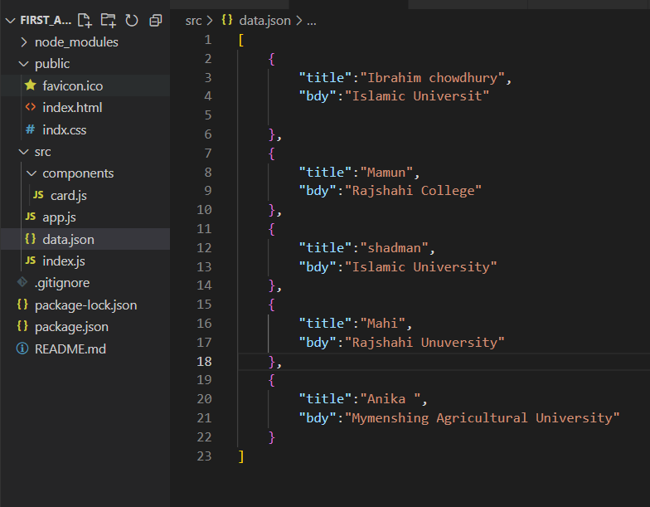

This json file contains some information or data by which we can make cards

After that, go to the app.js file and import Data from “./data.json”

And then map the data and the data in the card section

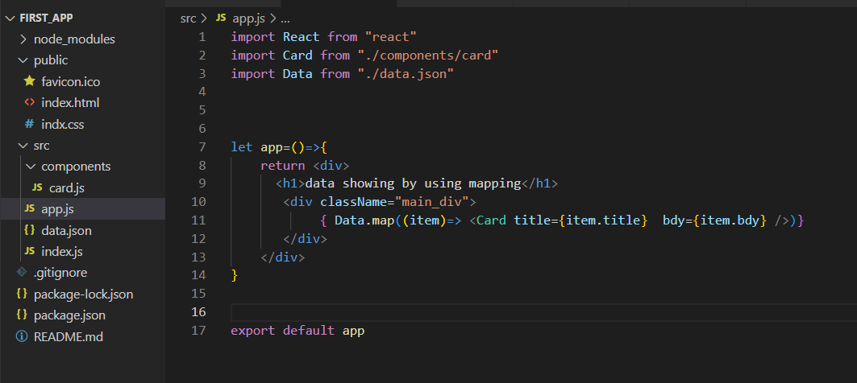

After mapping the data we will see the cards in the bowser

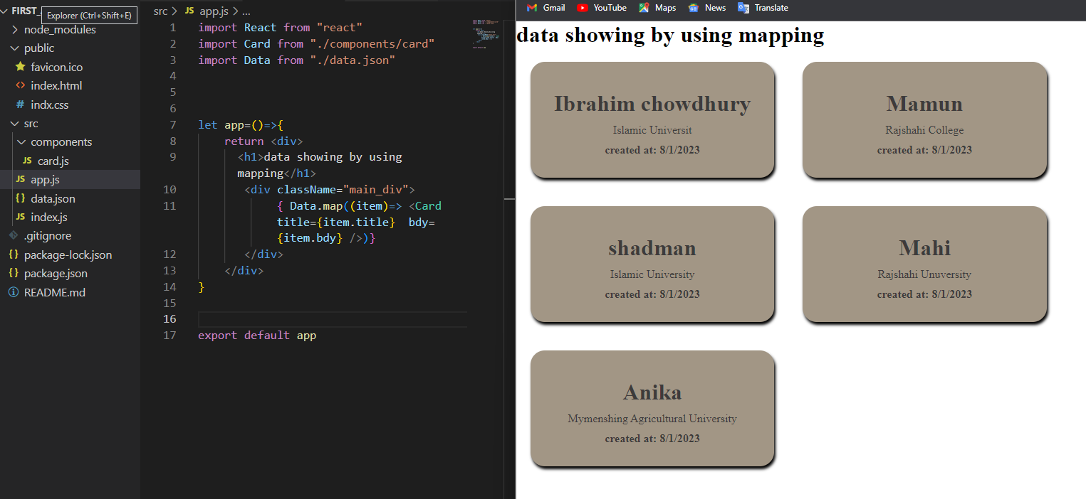

**Solution Of the error:**

After that when we go to the console of the browser then we then we can see an error in the console.

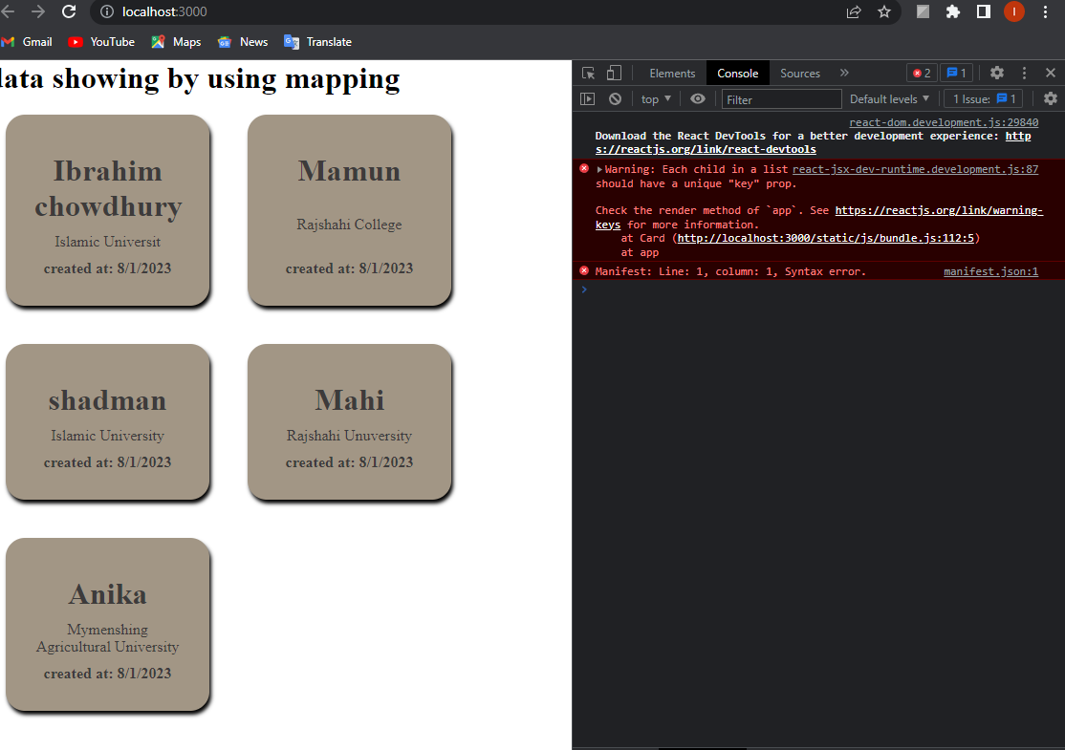

Here we should give a key of the props

To solve the problem we need to give a key value in the card section

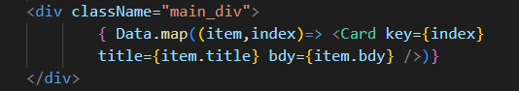

After using index in the key the error is solved

